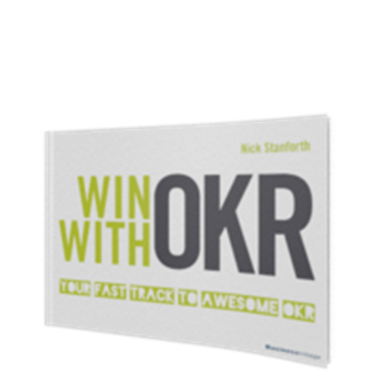
Nick Stanforth
WIN WITH OKR
Your Fast Track to Awesome OKR
1. Auflage BusinessVillage 2020
210 Seiten
ISBN-Buch 978-3-86980-575-7 24,95 €
ISBN-PDF 978-3-86980-576-4 19,95 €
ISBB-E-PUB 978-3-86980-577-1 19,95 €
Press Materials
http://www.businessvillage.de/presse-1117
Blurb
OKR, aka Objectives and Key results, makes the difference between setting strategic goals and actually achieving them. Entire teams focus on those few important things, which truly make a difference, bringing purpose, agility and transparency to the work they do. In three-month sprints, companies take quantum leaps and innovative pivots, whilst their teams establish a learning culture, constantly questioning how to not if they can overdeliver on the next audacious targets.
The power of OKR is truly impressive, but how should a team practically decide which priorities to ignore for three months? How does a leader let go a little without letting go too much? How do teams deal with the challenge of de-prioritizing their own dreams in order to support their colleagues and how do individuals learn to collaborate and deliver 10x more without sacrificing their personal wellbeing in the process?
Whilst the OKR methodology is simple to describe and easy to understand, experienced OKR practitioners know that the mindset behind this methodology is the true key to a successful implementation and return on energy invested.
As one of Europe’s first ever OKR consultants, our author Nick Stanforth shares his ground-breaking approach to a swift, successful and enjoyable OKR implementation for the first time. He shares valuable insights, gathered whilst training hundreds of OKR practitioners in the most diverse markets and coaching them throughout their transformation journey.
Regardless whether you are new to OKR or have been working with the methodology for years; whether you are a manager, team mate, agile PO or even an OKR trainer yourself, Nick goes beyond the standard theory of OKR and shares real-life examples of how his international client-base made OKR their own, repeatedly delivering audacious results and solving age-old puzzles in astonishingly short timeframes.
The Author
Nick Stanforth is on a mission to rid the workplace of boredom and depression.
As the founder of Progress Factors, he was one of the earliest adopters of Objectives and Key Results in Europe and helps large international companies implement the OKR methodology and establish the OKR mindset required for it to prosper.
Having studied Laser Physics, he began his career in automotive project management before running a company for 8 years and managing their own strategic transition. He and his team work globally with the ultimate goal of helping people to love their job by helping them to reconnect with the purpose of their work and deliver above and beyond their own expectations.
https://progressfactors.com

Press inquiries
BusinessVillage GmbH
Jens Grübner
Reinhäuser Landstraße 22
37083 Göttingen
E-Mail: redaktion@businessvillage.de
Phone: +49 (551) 20 99 104
Fax: +49 (551) 20 99 105
-------------------------------------
Geschäftsführer: Christian Hoffmann
Handelsregisternummer: 3567
Registergericht: Amtsgericht Göttingen

